

BHARAT SANCHAR NIGAM LIMITED
(A Government of India Enterprise)
Office of the General Manager
Telecom District, Dhenkanal-759 001

TENDER DOCUMENT
FOR
PRINTING OF
COMPUTER FORMS / BOOKS
FOR BILL PRINTING OF LANDLINE & MOBILE OF GMTD,DKL
FOR THE YEAR 2008-09

TENDER NO. D-305(1)/2008-2009/ 12 DATE 21.5.2008

Rs.563.00

SL.NO. CONTENTS PAGE NOS.
1. CHECK LIST : 3
- NOTICE INVITING TENDER : 4
3. SCOPE OF WORK : 5
4. EVALUATION OF TENDER : 6
5. PAYMENT & OTHER TERMS : 7
6. FORCE MAJURE : 8
7. AGREEMENT FORM : 9
8. PERFORMANCE SECURITY GUARENTEE BOND : 10
9. ANNEXTURE : 11
10. BID DOCUMENT FOR FINANCIAL : 12
11. FINANCIAL BID : 13

CHECK LIST

(A) Following points ( 1 to 5 ) Send along with the tender :

- EMD Receipt/DD is enclosed in First envelope marked as “Bid Security/EMD”.
- The tender document & all other documents establishing bidder’s eligibility & qualifications ( Mentioned in C ) are enclosed in second envelope & marked as “Qualifying Bid”.
- Rates will be quoted by the tenderer in the prescribed format are enclosed in third envelope & marked as “Financial Bid”.
- All the three envelopes containing (i) EMD/Bid Security, (ii) Qualifying bid (iii) Financial bid are properly sealed Preferably ( PVC Tape or wax sealed ) are placed in side a main cover & that should also be properly sealed preferably ( PVC Tape or wax sealed ) .
- All envelops three inner & one outer must bear the following:
- Tender No. b. Name of work of tender c. Name of the firm/bidder
The tenders which are not submitted in above-mentioned manner (1 to 5) shall be liable to be rejected. Tender must be addressed to DE (P&A) , O/o GMTD , Dhenkanal.

(B) Following Points ( 6 to 10 ) Must be checked while filling the Tender.

- The tender document in original duly filled in & signed by tenderer or the authorized representative along with seal on each page. All corrections & over writings must be initialed with date by the tenderer or his authorized representative. The rates have been quoted both in figures and words.
- The tender is not conditional.
- Original / Self attested “Power of Attorney” in case person other than the tenderer has sign the tender document
9. Self-declaration for certifying that none of the closed relative are employed in BSNL(Given in Page 11)
- if the tender document is downloaded from web site www.orissa.bsnl.co.in then a demand draft as per NIT for purchase of tender document is required to be enclosed

(C) Self Attested Photo copy of following documents for eligibility condition

- Self Attested copy of the registration of the firm/Article of Memorandum of association or partnership whichever applicable.
- Copy of NSIC ( If applicable )
- Self Attested copy of Sales Tax registration NO /VAT registration no.
- Self Attested copy of satisfactory completed at least supplying item similar to that of the respective tender costing not less than 2 lacs in during last 3 years in BSNL/MTNL/DOT/Central Govt./State Govt./PSU.

Bharat Sanchar Nigam Limited
(A Government of India Enterprise)
O/O GMTD, Dhenkanal-759 001.
…

TENDER NO. D-305(1)/2008-2009/ 12 DATE 21.5.2008

TENDER NOTICE

Sealed Tenders in the prescribed form are invited by the GMTD, Dhenkanal, on behalf of BSNL, from the bonafide and experienced contractors having experience in printing works in BSNL/PSU, for printing of computer forms/books for theTRA unit of GMTD, Dhenkanal year 2008-2009.
01. | Name of work | : | Printing of Departmental Books / forms in Dhenkanal Telecom District for the year 2008-2009
02. | Tentative cost of tender | : | Rs 4,00,000/-
03. | Cost of Bid document  (Non refundable) | : | Rs 563/-
04. | E.M.D. | : | Rs 10,000/-  ( Refundable after submission of SD)
05. | Security Deposit | : | 5 % of the Contract Value
06. | Mode of deposit for both Tender Paper and EMD. |  | D.D drawn in favour of Accounts Officer (Cash), BSNL,  O/o. G.M.T.D., Dhenkanal payable at Dhenkanal.
07. | Tender papers can be had from | : | SDE (Computer ), 2nd Floor, Room No - 209  O/o. G.M.T.D., Dhenkanal
08. | Period of issue of Bid documents | : | All working days between 11.00 hours to 16.00  From 23.5.2008 to 9.6.2008
09. | Time and Last date of submission of bid document | : | Up to 13.00 hours of 10.6.2008
10. | Time and date of opening of bid document | : | At 16.00 Hrs of Dt. 10.6.2008 If the date is declared as holiday the opening date will automatically extended to next working day.
11. | Criteria for issue of Tender paper | : | On production of:
11. | Criteria for issue of Tender paper | : | A | Copy of NSIC ( if applicable )
11. | Criteria for issue of Tender paper | : | B | Copy of Valid PAN Card
11. | Criteria for issue of Tender paper | : | C | VAT No.
11. | Criteria for issue of Tender paper | : | D | Proof of Bonafiedness of firm such as Registration Certificate of the firm / printing press Etc.( should be in the name of the bidder)
11. | Criteria for issue of Tender paper | : | E | Copy of Experience certificate of Rs. 2, 00,000/- During the last 3 consecutive years i.e 2005-06,2006-07,2007-08 from not below the rank of D.E for Printing work of PSU/Govt.
11. | Criteria for issue of Tender paper |  | F | Bidders should signed on each & every pages of both the documents carefully.
12. | Rejection of Tender | : | Unsealed, late receipt, incomplete tender, ambiguous and conditional tender will be rejected
13. | Down loaded Tender form | : | Down loaded from website must contain addition D.D of  Rs 563/- as cost of tender form.
The G.M.T.D., Dhenkanal reserves the right to accept or reject any or all the tenders without assigning any reason what so ever and is not bound to accept the lowest tender. For more details please visit us our website: - www.orissa.bsnl.co.in

The GMTD, Dhenkanal reserves the right to cancel or extend the last date of tender depending on the situation that warrants.

D.E (P&A)
O/o GMTD , Dhenkanal

.
- SCOPE OF WORK:
The work covers printing of Forms/books required by the office of GMTD, Dhenkanal as and when necessary as per the specification supplied to the contractor.

- QUANTUM OF WORK:
The different forms/books are to be printed as per the requirement for the year, 2008-2009. (Approx cost of work is Rs. 4,00,000/-) The quantum of work may vary depending on the actual requirement.

- QUALITY OF WORK:
As the quality of the printing materials, such as forms, books which are very often used by the public, reflects the image of the company, BSNL puts more emphasis on Quality and only on Quality in the present scenario where a number of Private Operators are in the field. Hence, the quality must be maintained as per the terms & conditions of tender otherwise necessary penalty, as deemed fit, will be imposed and contract will be terminated.

- SPECIFICATION OF WORK:
All the forms/books are to be printed as per the specification that will be supplied to the printer at the time of printing. The quality & paper has also been selected for different types of forms.

- TIME OF EXECUTION:
The time of execution will be as per the supply order, to be issued to the contractor by the General Manager Telecom District, Dhenkanal.

- SUPERVISION OF WORK:
From the BSNL side, the Telecom District Authority or any of his representative/representatives shall supervise the workmanship & other works related to the printing and certify its quality.

- OTHER CONDITIONS:
(a) Cost of tender paper is Rs. 563/-, which may be paid in cash or in the shape of DD as has been described earlier.
(b) The SSI units registered with NSIC are exempted from paying EMD, but copies of valid registration are to be enclosed with the tender. Original will be verified at the time of opening of the technical bid.
(c) The sample papers for the forms/books avaible with SDE (Comp), O/o-GMTD, DKL may be please be seen by the bidder from 10.30 a.m to 5.00 p.m
- PREPARATION OF TENDER BIDS:
The tender will be of two-bid system. One envelope superscribed as FINANACIAL BID will contain the Rate Sheet only where the bidder will quote the rates. The Second Envelope superscribed, as TECHNICAL BID will contain all other documents including the EMD. Both the envelopes will be kept in a third envelope superscribed as TENDER FOR PRINTING OF COMPUTER FORMS/BOOKS OF GMTD, DHENKANAL FOR THE YEAR 2008-09 and addressed to DE (P&A), O/O GMTD, Dhenkanal. All the three envelopes must be sealed properly. The Tendering Authority will not be responsible for any loss / replacement of papers in the tender bids, if not sealed properly.

- DROPPING OF TENDER:
The tender complete in all respect is to be dropped in the Tender Box available in the official chamber of Divisional Engineer (P&A), O/O GMTD, Dhenkanal before the stipulated date and time. Late received tenders will not be considered at all. Tender may be sent in the above address by Registered Post/Courier Services also. BSNL will not be responsible for delay/loss of tender through postal/courier services.
.
- OPENING OF TENDER:
The tender will be opened on the prescribed date and time in front of the bidders those who like to attend there. Technical bids will be opened first and checked. Financial bids of those bidders who qualify in the Technical bids checking will be opened on the same day or later which will be declared at the time of bid opening. The bid shall remain valid for 90 days after the date of opening bids.

11. EVALUATION OF TENDER:

- The Tender Evaluation Committee will evaluate the tenders as per criteria formulated by the committee.

- The rate of each forms/books should be quoted for printing with paper, for the quantity mentioned in column (5) of each item in Annexure-I. The tenderer is required to submit the sample of papers and cards with the tender paper positively and non-submission of the same will liable for rejection of tender. The tenderer is required to take sample paper at the time of receiving the tender paper from SDE (Comp) of GMTD Office, Dhenkanal.

- The “Specimen” of forms/books to be printed can be seen in any working day in the General Section, O/O GMTD, Dhenkanal before submission of tender paper.

- The tenderer shall deposit an EMD of Rs. 10,000/- (Rupees ten thousand ) only through Bank draft of any Nationalized Bank located at Dhenkanal payable to “Accounts Officer (cash), BSNL O/O GMTD, Dhenkanal” along with the tender paper, Tender without EMD will not be considered, EMD so deposited by the unsuccessful bidders will be refunded after finalization of tender without interest. Successful tenderer has to deposit 5% of contract value as performance security deposit. The performance security deposit can be submitted in the form of P.B.G in the format enclosed in the tender. Failure to comply with the order from time to time during the contract period in part or in full, the security deposit shall be forfeited by the GMTD, BSNL, Dhenkanal.

- The tenderer shall enclose current “VAT registration” along with tender paper.

- The quality of paper to be used in each form/book is mentioned in column (3) of Annexure-I and sample to be enclosed.

- Failure to comply with any of the above terms and conditions the tender shall be summarily rejected.

- In case of any defect noticed in printing or quality of papers used for the purpose of printing, the undersigned reserves the right to reject the printing materials supplied by the contractor and Security Deposit deposited by the contractor will also be forfeited.

- The undersigned is not bound to accept the lowest tender and reserves the right to cancel any or all the tenders without assigning any reason thereof.

- The successful tenderer will deliver the printing materials to the O/O GMTD, Dhenkanal from time to time for which no transportation charges will be paid.

- Rate may be quoted in the items against printing & binding both, where binding is required. No extra binding charges will be paid in any binding works.

l) The successful tender will have to sign an agreement on a stamp paper of Rs. 50/- with GMTD, Dhenkanal before issue of LOI and after submission of the Performance Security deposit in 5% of the contract value.

m) The tender may be extended for another one year, if so desired by the G.M.T.D., Dhenkanal.

n) The tender is valid for one year from the date of signing the agreement and the tenderer is to carryout the work at the approved rate during the valid period.

- The GMTD, Dhenkanal reserves the right to distribute the work among a number of bidders, if required.
- On sub-mission of PBG,EMD will be refunded for successful bidder.

    - PAYMENT AND OTHER TERMS:
- Payments shall be made against the bill, which have to be submitted in duplicate.

- The payment shall be made through Account Payee Cheques after successful completion of the work and its complete delivery.

- The tenderer is to indicate the name of the bank and A/C Number on which A/C Payee Cheques shall be issued.

- Penalty @ 0.5 % of the total cost of work order shall be imposed for every one day of delay in completion of assigned work. The total penalty will be limited to 5% of total cost of work order and thereafter the tenderer will be black listed.

    - DOCUMENTS TO BE SUBMITTED ALONG WITH TENDER:
      - Valid PAN CARD and VAT registration.

      - The experience certificates for carrying out printing works of an amount of minimum two Lakh in last three financial years from an officer not below the rank of Dy.GM, or equivalent of Central Government./State Government./PSU.

      - If the tender is submitted by a firm other than an individual, a certificate authorizing the person to sign the tender papers may be enclosed.

      - Earnest Money of Rs. 10,000/- (Rupees ten thousand only) in the shape of Bank Draft is to be submitted.

      - Proof of bonafiedeness of firm such as Registration Certificate of the firm/printing press etc.

- FACTORS FOR QUOTING THE RATE:

  - The tenderer is to quote the rate for the books/sheets indicated against the items in the tender paper Financial Bid.

  - The rate for every affiliation/decrease in sheets in the set will be proportionately charged.

15. TERMINATION OF INSOLVENCY.

BSNL may also by giving written notice and without compensation to the contractor terminate the contract if the contractor becomes unwilling bankrupt or otherwise in any way without affecting the right of action or remedy as hirer.

16. FORCE MAJURE.
If any time, during the continuance of this contract, the performance in whole or in part by either party of any obligation under this contract is prevented or delayed by reason of any war or hostility, acts of the public enemy, civil commotion, sabotage, fires, floods, explosions, epidemics, quarantine restrictions, strikes, lockouts or act of God (Herein after referred to as events) provided notice of happenings, of any such eventuality is given by either party to the other within 21 days from the date of occurrence thereof, neither party shall by reasons such events be entitled to terminate this contractor nor shall either party have any claim for damages against the other in respect of such on performance or delay in performance under the contract shall be resumed as soon as practicable after such an event may come to an end or cease to exit, and conclusive, provided further that if the performance in whole or part of any obligation under this contract is prevented or delayed by reason of any such event for a period exceeding 60 days either party may, at his option terminate the contract.

17. ARBITRATION.
  - In the event of any question, dispute or difference arising under the agreement or in connection there with (except as to matter the decision to which specifically provided under this agreement), the same shall referred to sole arbitration of the GMTD, Dhenkanal, BSNL. In case his designation is changed or his office is abolished then in such case to the sole arbitration of the officer for the time being entrusted whether in addition to the function of the GMTD, Dhenkanal or by whatever designation such officers may be called (herein after referred to as he said officer) and if the GMTD, Dhenkanal or the said officer is unable or unwilling to act as such, than to the sole arbitration of some other person appointed by the CGM/PGM/TDM or the said officer. The agreement to appoint an arbitrator will be in accordance with the Arbitration and Conciliation act, 1996.

  - The arbitrator may from time to time with the consent of bother the parties enlarge the time frame for making and publishing the award, Subject to aforesaid arbitration and conciliation Act, 1996 and the rules made the under, any modification thereof for the time being in force shall be deemed to apply to the arbitration proceeding under this clause.

  - The Venus of the arbitration proceeding shall be office of General Manager, telecom District, BSNL, BSNL at Dhenkanal or such other place as the arbitrator may decide.

Dy. General Manager,
O/O GMTD, Dhenkanal.

AGREEMENT FORM

An agreement entered into between the GENERAL MANAGER TELECOM DISTRICT, DHENKANAL and Sri________________________________________
of__________________________________________________________________
__________________________________________________________(Contractor)
on this day of________________2008 for the work of ________________________

Whereas in response to the Tender Notice No ________________________
Dated. __________, The tender for the work of ________________________________
has been approved by the General Manager Telecom District, Dhenkanal vide his memo No._____________date________ to carry out the said work under the terms and conditions of the tender, initially for a period of one year from Dt__________to Dt.___________.

Further, Sri____________________________________Contractor selected for the above work agrees to carry out the work under the General Manager Telecom District, Dhenkanal for the period from _____________to ____________at the rate approved by the General Manager, Telecom District, Dhenkanal and also further undertakes to abide by the terms and conditions as prescribed in the approved tender.

Sri________________________________further agrees that in case he fails to carry out and complete the said work within the specified time given in work order, he shall have no claim for refund of Earnest Money and/or Security deposit and he shall be liable to bear with the loss sustained to the Department due to delay/damage/negligence caused by the contractor.

Signature of Contractor Signature of Dy.G.M (Admn)
Name ______________ Name___________________
Address_____________ Address__________________
____________________ _________________________

Signature of Witness Signature of witness
Address______________ Address__________________
____________________ _________________________

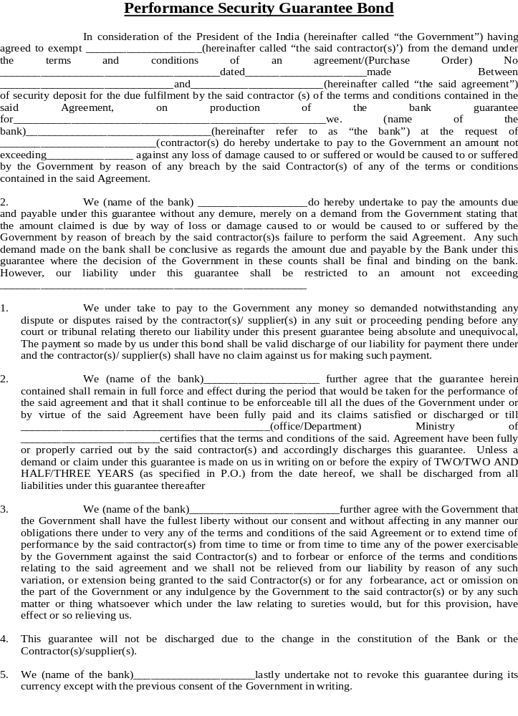

Annexure

Certificate on non-participation of near relatives in the tender.

I, Sri__________________________________________________________
S/O________________________________________________________________
Village______________________________P.O.____________________________P.S._________________________________Dist.___________________________hereby certify that none of my relative(s) defined below is/are employed in BSNL unit. In case at any stage, it is found that the information given by me is false/incorrect, BSNL shall have the absolute right to lake any action as deemed fit, without any prior intimation to me.

Signature of bidder_________________________

Date.

Definition of near relatives.

No sub-contracting is permissible by BSNL. The near relatives of all BSNL employees (Non-executive employees) working in telecom District, Dhenkanal & executive employees (also called Group-A & Group-B officers) working in Orissa Telecom Circle either directly recruited or on deputation are prohibited from participation in this tender. The near relatives for this purpose are defined as :

- Members of a Hindu Undivided Family.

- They are husband and wife

- The one is related to the other in the member as father, mother son(s), son’s wife (daughter-in-law). Daughter(s) & daughter’s husband (son-in-law), brother(s) & brother’s wife, sister(s) sister’s husband (brother-in-law), relative is working in the units of BSNL as defined above. In case of proprietorship firm the certificate will be given by the proprietor, for partnership firm certificate will be given by all the partners and in case of limited company by all Directors of the Company. Any breach of these conditions by the company or firm or any other person, the tender/work will be cancelled and earnest money/security deposit will be forfeited at any stage whenever it is noticed. The BSNL will not pay any damages to the company or firm or concerned person. The company or firm or the person will also be debarred from further participation in the concerned unit.

Signature of bidder.

BHARAT SANCHAR NIGAM LIMITED
OFFICE OF THE GENERAL MANAGER, DHENKANAL

BID DOCUMENTS
FOR
PRINTING OF
COMPUTER FORMS / BOOKS
FOR BILL PRINTING OF LANDLINE & MOBILE OF GMTD,DKL

( FINANCIAL )

TENDER NO. D-305(1)/2008-2009/ 12 DATE 21.5.2008
Financial Bid
( To be given in a Separate Sealed Envelope )

Sl.  No. | Specification | Quantity  ( Annual Requirement )  in thousand | Rate per 1000
Sl.  No. | Specification | Quantity  ( Annual Requirement )  in thousand | Fig. in nos. | Fig. in word
1 | 15x12x1(80 GSM) Pre  preprinted Telephone  Phone bill | 300
2 | 15x12x1 (80 GSM)  preprinted Pay phone bill foms | 50
3 | 10x12x1 (80 GSM)  Plain with BSNL Logo | 150
4 | 10x12x2 (80 GSM)  Plain with BSNL Logo | 50
5 | 6x12x1 (80 GSM)  Counter receipt | 50
6 | 15x12x1 (80 GSM)  Plain with BSNL Logo | 70
7 | 15x12x2 (80 GSM)  Plain with BSNL Logo | 50
8 | 10X12X1 ( 80 GSM ) Preprinted Duplicate Telephone Bill | 50
9 | Mobile bill form J.K colour with Logo White (75 GSM ) | 300

The above rates are inclusive of all taxes printing charges and transportation charges up to BSNL Admn. Building, O/o GMTD, Dakshinakali Road, Dhenkanal.

Signature of Bidder
Postal Address :
Name :
Village:
P.O.
Dist.
PIN :
Telephone No.

Rates Quoted are inclusive of all taxes.

